- In-Service Days Monday 13 and Tuesday 14 November
- Children in Need - Friday 17 November
Price list for Children in Need
Bake sale items priced 50p-£1
Guess the spots in the jar competition 50p
P1-3 art competition 20p
P1-3 art competition 20p
Spot treasure hunt 50p
Dress as ‘spotacularly’ as you please – minimum £1 donation
- School Open Evening Tuesday 21 November 6pm-7pm
- Nursery Christmas Performance 15 December
- P1 and P2 Nativity 20 December
- P3-5 Nativity 20 December
- P6-7 Nativity 20 December
- Last day of term Friday 22 December
- Term 3 begins Monday 8 January

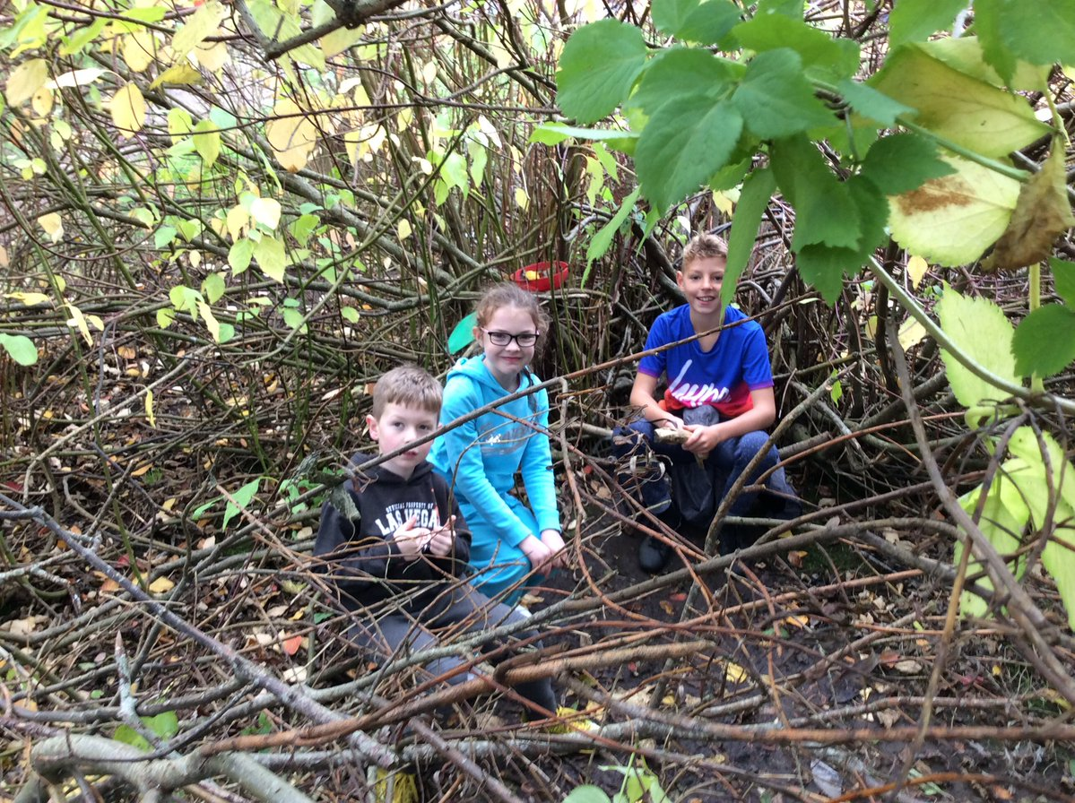 |  | Newtonhill  - Newsletter  - 10 November  - 2017
 |  | Dates For Your Diary

Term 2
Term 2 is always busy and exciting in school. Halloween, Guy Fawkes and the lead up to Christmas creates an exciting buzz amongst all pupils (and staff )
We had an eventful first week back. Primary 3, Primary 3/4, Primary 4 and Primary 4/5 took part in a drama workshop based on the novel ‘The Owl Who Was Afraid of the Dark’. The pupils loved the learning activities and the day was a great success. On Wednesday 1st November and Friday 3rd November we held two Outdoors Days with visitors from the RSPB, Biodiversity Centre, Aberdeen Astronomical Society, Mucky Boots, STEM and Aberdeenshire Forest Rangers. As well as the visits the pupils were engaged in learning activities in and around the school developing outdoor skills and improving school grounds. Both days were a huge success and everyone at Newtonhill would like to thank all our visitors and all the parents that gave up their time to come and help on the days.

Techfest Dome
Next week on Thursday 16 and Friday 17 November all pupils will also have the opportunity to experience the Techfest Dome. This will give all pupils a chance to participate in an interactive and immersive journey through space and time and link to the key experiences and outcomes for Space and Forces.
In-Service Days
School is closed to pupils on the 13th and 14th November. Staff will be working on aspects of the school improvement plan. On the Monday staff will be developing reading and have an opportunity to engage with technologies to support the curriculum. On Tuesday all Primary staff from Newtonhill will meet with staff from the other primaries in the Portlethen Cluster to receive training on Numicon. This will support and enhance the learning and teaching of numeracy.

Open Evening
As part of our commitment to further engage and provide reporting opportunities to parents we are holding an open evening on Tuesday 21st November from 6.00pm - 7.00pm. This will give parents and carers an opportunity to come into class with your child, see their classroom, around the school and other class areas your child is taught in. It will give your child the opportunity to share their learning and discuss their work with you. Separate information will follow in due course.

Pupil Council
This year’s Pupil Council are very busy. They are currently consulting with classes about various aspects of school that they would like to develop or improve. At the moment one of their ideas is to look at homework across the school.

Rights Respecting School Group
We have recently been awarded our Recognition of Commitment – the first stage in UNICEF’s Rights Respecting School Award. We will continue to work towards this and the RRS Group will send out their own newsletter later in the term. Please get in touch if you would like to be involved with the group.

Christmas
Our Christmas arrangements are being finalised. We do like to do something a little different every year and this year is no exception.
We will have 3 school nativity performances this year.
All Primary 6-7 pupils will be participating in a nativity together. Primary 3-5 will be performing together and primary 1-2 will be performing together.
We will be having all 3 performances on the same day.
Primary 1-2 nativity – ‘Whoops-a-Daisy Angel’ will be at 9.30am on Wednesday 20th December.
Primary 3-5 nativity – ‘Children Of The World’ will be at 2.00pm on Wednesday 20th December.
Primary 6-7 nativity – ‘Feliz Navidad’ will be at 6:30pm on Wednesday 20th December.
Information about tickets will be issued in due course but these will be limited to a certain amount per family for each performance due to health and safety regulations.
Nursery are also organising a special Christmas performance this will take place on Friday 15th December. Nursery will issue further details.
Other Christmas arrangements are still being finalised and we hope to be able to inform you in the week ahead of what these are.
Cycling
Please can you ensure that if your child cycles to and from school they are suitably attired for cycling home on dark evenings and that their bicycle has lights.
Children in Need
Friday the 17th is the annual Children in Need day. Primary 6/7 are running this year’s fundraising for the event in school. A letter was emailed to all parents this week.
School Resources
As a school we do provide pens and pencils for pupils to use. We would really appreciate if all pupils could also come to school with their own pencils, pens etc.

Weather
We hope the winter months are kind to us but in the event of extreme winter weather there are several ways to access school closure information.
*The Aberdeenshire website www.aberdeenshire.gov.uk/closures *Information telephone line 0370 054 4999 & Pin no. 02 2360
*Twitter
http://twitter.com/aberdeenshire
Local radio stations will also announce closures as soon as the school has updated the information on the Aberdeenshire Council Website.

We are looking forward to an exciting and productive term.
Lesley Tullock
Head Teacher

