To All Parents and Carers
Positive Behaviour at Newtonhill
Pupils at Newtonhill are working together with staff to develop and improve our Positive Behaviour Policy
There are several aspects that blend together to create our vision and policy for Newtonhill.
Restorative Approaches
The school have introduced Restorative Approaches and this is being implemented and developed across all schools in the Portlethen area. Miss Bainbridge has been training P5 and P6 pupils to be ‘playground superheroes’ (PGSH) and staff have been trained in restorative questioning and approaches.
Golden Time and Golden Rules
Golden Time is supposed to be a reward for focused learning and good behaviour. Pupils are encouraged to follow the Golden Rules. Pupils and staff feel that Golden Time has lost its value and true meaning. The Pupil Council have been asking classes how to change, develop and improve this.
Reward Systems-
Each class employs a positive behaviour reward system. This can change from class to class but fundamentally pupils will gain rewards in some form for positive behaviour, effort and attitude. In addition to this we hope to develop a reward system in the new school session by introducing a School House Points system.
Sanctions
The Pupil Council raised the issue of behaviour with Mrs Tullock as something they would like to improve across the school. They consulted all classes and discussed possible solutions. The Pupil Council decided sanctions and warnings were a good idea. Pupils and staff felt that the sanctions employed across the school should be more consistent. Following on from the most recent Pupil Council meeting a system was agreed and the Pupil Council are now consulting pupils on agreed behaviours and sanctions. The Pupil Council will share this with all families in the near future.

Anti –bullying
Children will and do fall out with each other and have disagreements on a daily basis. In school we promote positive friendships and support children that are finding friendships difficult. Children are aware of the difference between arguments, fall outs and disagreements and bullying. Occasionally we do have to deal with children being persistently mean or unkind. This targeted behaviour is not tolerated. Pupils are always encouraged to let an adult know. This can be a PSA, PGSH, the class teacher or the depute head teachers and head teacher.
RESPECT
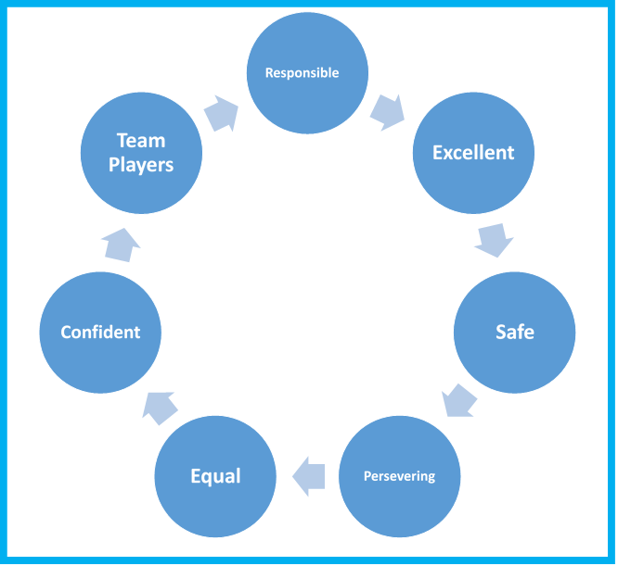
Our school motto is RESPECT. This is key to our ethos and vision at Newtonhill. All pupils are regularly reminded of our motto, what it stands for and how the word ‘Respect’ is a fundamental part of how we work, perform and learn at Newtonhill.

Parent Survey
The Pupil Council are asking parents and carers to share their views to help improve all aspects of behaviour at Newtonhill. Please could you complete the following questionnaire and return to the Pupil Council at school.
Pupil Council questionnaire for all parents and carers.
Please could you answer the following questions and return this
questionnaire ASAP. Thank You.
Isla Johnstone (Chair) and Ayo Atti (Vice-Chair)

- Do you think that behaviour at Newtonhill School is :
Very good ⃝ Good ⃝ Average ⃝ Poor ⃝ Very poor ⃝
- Do you know and understand what Golden Time is?
Yes ⃝ No ⃝
- Pupil council have consulted with all pupils and we think a system of warnings and sanctions would help improve and support better behaviour and better learning. Do you think yellow cards, red cards and sanctions are a good idea?
Very good ⃝ Good ⃝ ok ⃝ Not good ⃝ Terrible ⃝
- If you do not like this idea please can you comment why or make an alternative suggestion.

- Do you have a clear understanding of the behaviour the school expects from pupils?
Yes ⃝ No ⃝
- Do you have any further suggestions about our school’s positive behaviour systems that the pupil council could help improve?

